26.5: a) 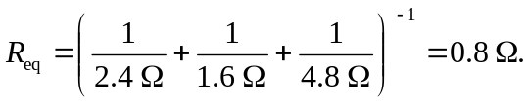
b)
c)
d) When in parallel, all resistors have the same potential difference over them, so here all have V = 28 V.
e)
f) For resistors in parallel, the most power is dissipated through the resistor with the least resistance since 